- install.packages("dplyr"). library(dplyr)

- MoosePopulation <- read.csv("BIO1002_Rassignment /MoosePopulation.csv")

- View(MoosePopulation) MoosePopulation <- na.omit(MoosePopulation)

- MoosePopulation <- select(MoosePopulation, Ecoregion, Year, Area, Estimated_Moose_Pop)

- A. > min(MoosePopulation$Year)
[1] 1904
> #The oldest opservation was made in 1904

B. max(MoosePopulation$Estimated_Moose_Pop)
[1] 41250
> #The highest estimated moose population is 41250 This is for a particular ecoregion

- MoosePopulation <- mutate(MoosePopulation, MooseDensity = Estimated_Moose_Pop / Area)

- plot(MoosePopulation$Year, MoosePopulation$MooseDensity,
+ xlab = "year",
+ ylab = "Moose per sq km",
+ main = "Moose density in Newfoundland ecoregions over time")

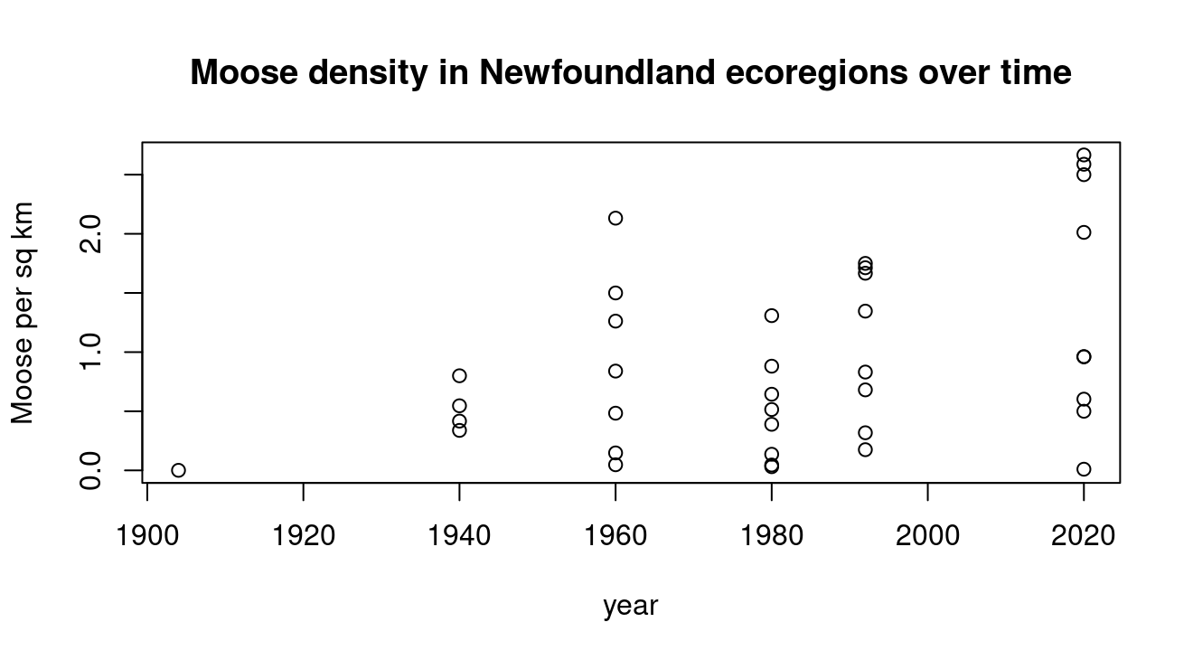

- A. MooseDataWest <- filter(MoosePopulation, Ecoregion == "Western_Forests")

B. . plot(MooseDataWest$Year, MooseDataWest$MooseDensity,
+ type = l
+ xlab = "year",
+ ylab = "Moose per sq km",
+ main = "Moose density in the Western Forest Region in Newfoundland over time")

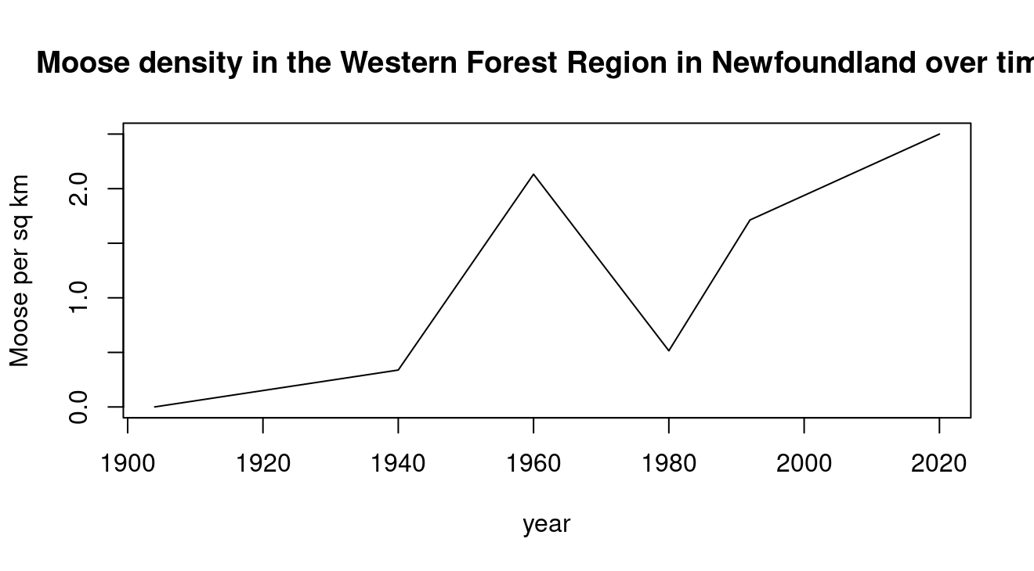

- A. MoosePopulation_2020 <- filter(MoosePopulation, Year == "2020")

B. MoosePopulation_2020_b <- filter(MoosePopulation_2020, MooseDensity > 2.0)

C. arrange(MoosePopulation_2020_b, desc(MooseDensity))
# A tibble: 4 × 5
Ecoregion Year Area Estimated_Moose_Pop MooseDensity
<chr> <dbl> <dbl> <dbl> <dbl>
1 Northern_Peninsula_Forests 2020 12000 32000 2.67
2 North_Shore_Forests 2020 8400 21740 2.59
3 Western_Forests 2020 6800 17000 2.5
4 Central_Forests 2020 20500 41250 2.01

MoosePopulation_final <- MoosePopulation %>%
+ filter(Year == 2020) %>%
+ filter(MooseDensity > 2.0) %>%
+ arrange(desc(MooseDensity)) %>%
+ print()
# A tibble: 4 × 5
Ecoregion Year Area Estimated_Moose_Pop MooseDensity
<chr> <dbl> <dbl> <dbl> <dbl>
1 Northern_Peninsula_Forests 2020 12000 32000 2.67
2 North_Shore_Forests 2020 8400 21740 2.59
3 Western_Forests 2020 6800 17000 2.5
4 Central_Forests 2020 20500 41250 2.01

Part II

- SaplingStudy_Clean <- na.omit(SaplingStudy)

- A. Moose_Browsing_Pressure <- SaplingStudy_Clean %>% group_by(Ecoregion) %>% summarize(MeanBrowsing = mean(BrowsingScore, na.rm = TRUE))
> print(Moose_Browsing_Pressure)

B. Ecoregion MeanBrowsing
<chr> <dbl>
1 Avalon_Forests 2
2 Central_Forests 4
3 EasternHyperOceanicBarrens 2.4
4 Long_Range_Barrens 2.6
5 Maritime_Barrens 1.83
6 North_Shore_Forests 4.38
7 Northern_Peninsula_Forests 4.57
8 StraitOfBelleIsleBarrens 1
9 Western_Forests 4.5
> #North Shore Forests has the highest browsing score
>#Strait of belle isle Barrens has a lowest Browsing score

A. > Avg_Tree_Hight <- SaplingStudy_Clean %>% group_by(Ecoregion) %>% summarize(MeanHeight = mean(Height, na.rm = TRUE))
> print(Avg_Tree_Hight)
# A tibble: 9 × 2
Ecoregion MeanHeight
<chr> <dbl>
1 Avalon_Forests 32.4
2 Central_Forests 23.8
3 EasternHyperOceanicBarrens 31.6
4 Long_Range_Barrens 29.9
5 Maritime_Barrens 26.7
6 North_Shore_Forests 22.3
7 Northern_Peninsula_Forests 19.9
8 StraitOfBelleIsleBarrens 25.4
9 Western_Forests 18.9

B. #In the ecoregions Northern Peninsula Forest and in the Western Forest the average height for the trees are below 20
4. Browsing_Sapling_Score<- SaplingStudy_Clean %>% group_by(Species) %>% summarize(MeanBrowsing = mean(BrowsingScore, na.rm = TRUE))
> print(Browsing_Sapling_Score)
# A tibble: 6 × 2
Species MeanBrowsing
<chr> <dbl>
1 Alder 4.25
2 Balsam_Fir 3.14
3 Black_Ash 5
4 Black_Spruce 2.33
5 White_Birch 3.14
6 Willow 4.31
> #the black ash has the highest average browsing score and the black spruce has the lowest aveage browsing score

5. > BalsamFir <- SaplingStudy_Clean %>% filter(Species == "Balsam_Fir") %>% group_by(Ecoregion) %>% summarize(mean_browsing = mean(BrowsingScore, na.rm = TRUE))
> print(BalsamFir)
# A tibble: 7 × 2
Ecoregion mean_browsing
<chr> <dbl>
1 Avalon_Forests 2
2 Central_Forests 3.5
3 EasternHyperOceanicBarrens 2
4 Long_Range_Barrens 1
5 Maritime_Barrens 2
6 North_Shore_Forests 4.5
7 Northern_Peninsula_Forests 4.25

6. barplot( BalsamFir$mean_browsing, names.arg = BalsamFir$Ecoregion, xlab = "Ecoregion", ylab = "Mean Browsing Score", main = "Mean Browsing Scores for Balsam Fir Trees in Different Ecoregions Across Newfoundland", col = "orange", cex.names = 0.6)

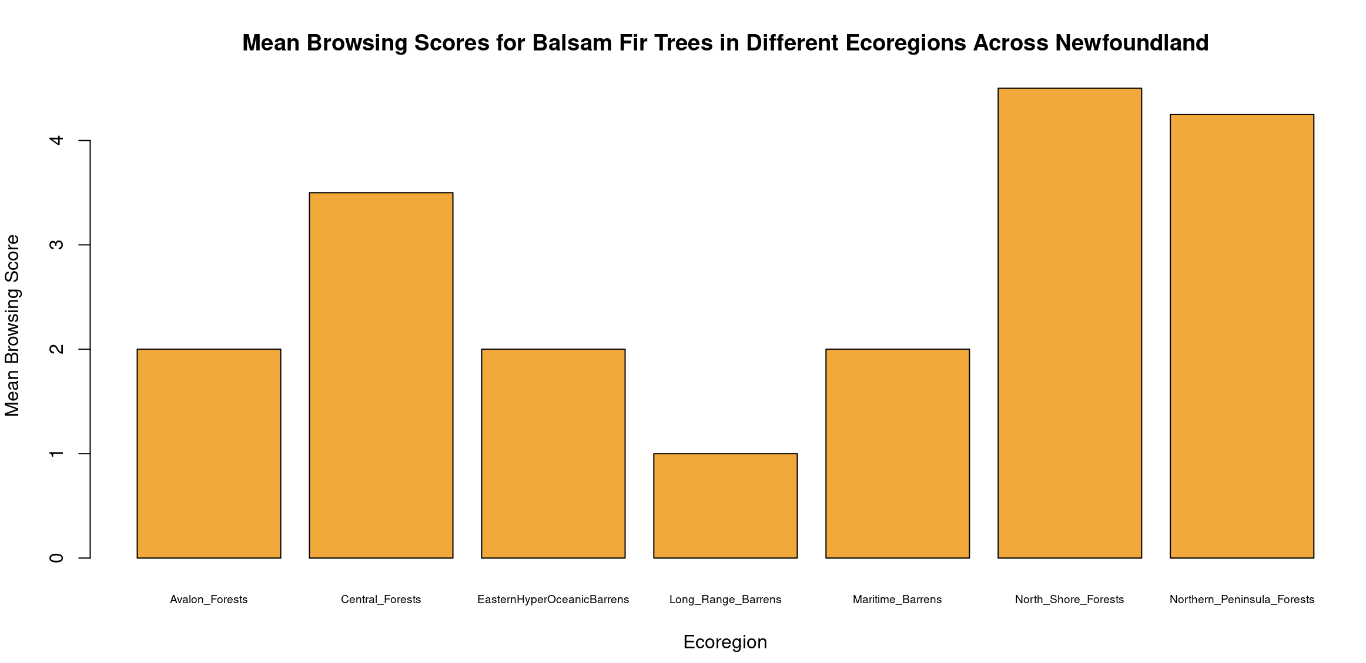
7. A BlackSpruce <- SaplingStudy_Clean %>% filter(Species == "Black_Spruce") %>% group_by(Ecoregion) %>% summarize(mean_browsing = mean(BrowsingScore, na.rm = TRUE))
> prin t(BlackSpruce)
# A tibble: 8 × 2
Ecoregion mean_browsing
<chr> <dbl>
1 Avalon_Forests 0.5
2 Central_Forests 3
3 EasternHyperOceanicBarrens 0
4 Long_Range_Barrens 2
5 Maritime_Barrens 0
6 North_Shore_Forests 4
7 Northern_Peninsula_Forests 4
8 Western_Forests 3.5

B. 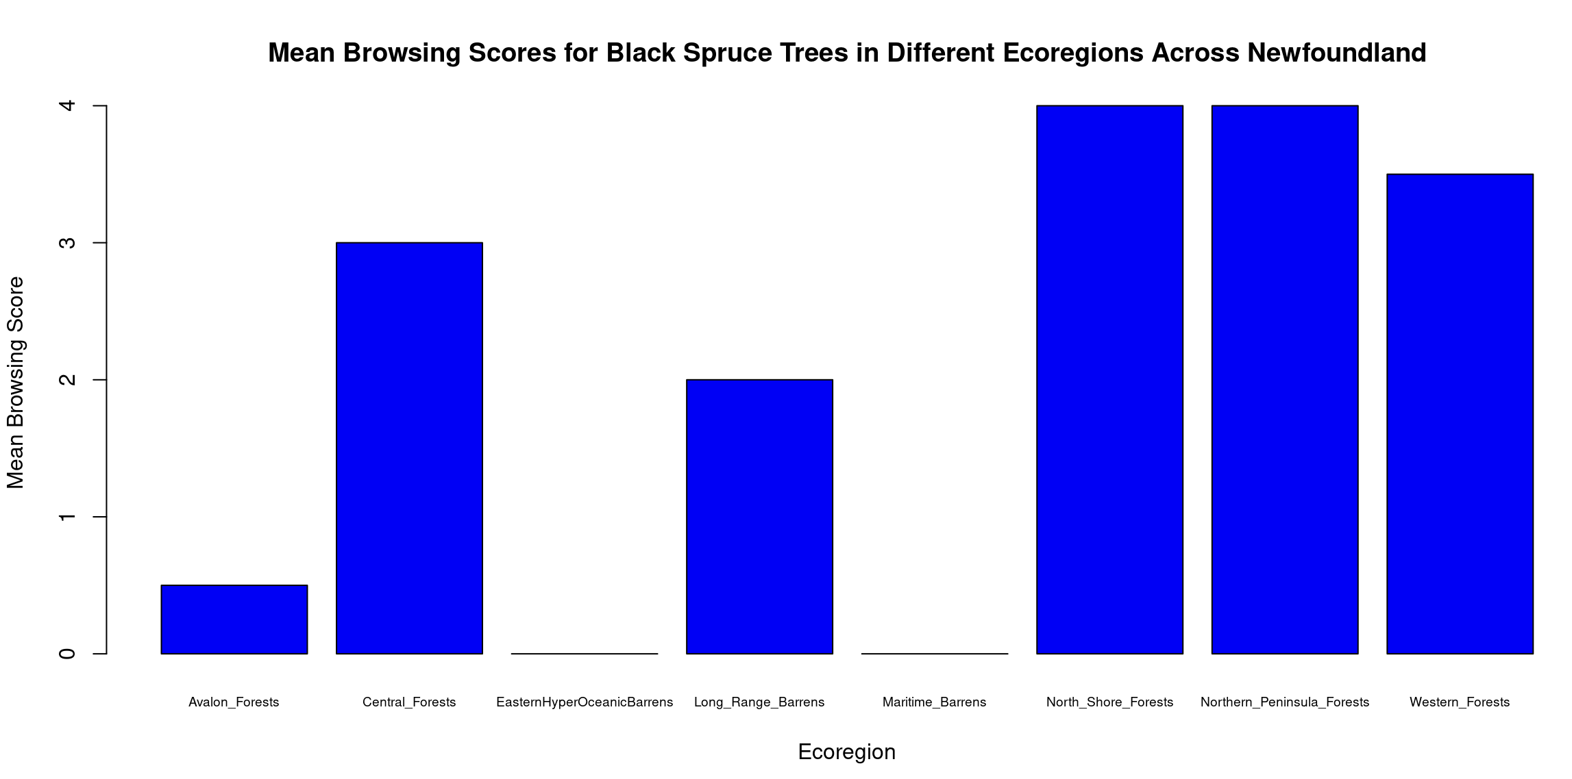

barplot( BlackSpruce$mean_browsing, names.arg = BlackSpruce$Ecoregion, xlab = "Ecoregion", ylab = "Mean Browsing Score", main = "Mean Browsing Scores for Black Spruce Trees in Different Ecoregions Across Newfoundland", col = "blue", cex.names = 0.6)

C. #There are signifity lower browsing score for black spruce trees in multiple ecoregions like the Eastern Hyper Oceanic Barrens, the maritime barrens and the avalon forests.

8. EcoregionTally <- SaplingStudy_Clean %>% group_by(Ecoregion) %>% tally() %>% print()
# A tibble: 9 × 2
Ecoregion n
<chr> <int>
1 Avalon_Forests 5
2 Central_Forests 5
3 EasternHyperOceanicBarrens 5
4 Long_Range_Barrens 5
5 Maritime_Barrens 3
6 North_Shore_Forests 8
7 Northern_Peninsula_Forests 7
8 StraitOfBelleIsleBarrens 1
9 Western_Forests 5

9. SpeciesTally <- SaplingStudy_Clean %>% group_by(Species) %>% tally() %>% print()
# A tibble: 6 × 2
Species n
<chr> <int>
1 Alder 8
2 Balsam_Fir 11
3 Black_Ash 1
4 Black_Spruce 9
5 White_Birch 7
6 Willow 8

10. A. #No I dont think this data set is evenly distributed. The ecoregion Strait of Belle Isle barrens only has one entry in this data set and the Black ash tree was only recorded once aswell.

B. # It is important to recognize bias in ecological datasets so you don't make assumptions or draw incorrect conclusions because wildlife organizations rely on these datasets to make decisions about nature.

Part 3
1.
> Moose_2020b <- MoosePopulation %>%
+ filter(Year == 2020) %>%
+ mutate(MooseDensity = Estimated_Moose_Pop / Year)
> moose_sap <- left_join(Moose_2020b, SaplingStudy_Clean, by = 'Ecoregion', relationship = "many-to-many")
> print(moose_sap)
2. Avg_Browsing_And_Density <- moose_sap %>% group_by(Species, Ecoregion) %>% summarize(mean_browsing = mean(BrowsingScore, na.rm = TRUE), mean_density = mean(MooseDensity, na.rm = TRUE))

3. A) Yes, there is a pattern that suggests that at low moose density, the browsing varies more strongly among species but as density increases the browsing scores are closer together which means they shift to more generalists.

B) Moose favour willows the most because they are at the top for all moose densities. Moose dislike black spruce trees the most because they are the lowest for all densities.

C)

collisions2020 <- c(56, 60, 14, 36, 48, 10, 40, 110, 6)
> human_pop <- c(18000, 12000, 4000, 75100, 24000,3500, 32000, 270000, 2300)
> study_sites <- c("North_Shore_Forests","Northern_Peninsula_Forests", "Long_Range_Barrens","Central_Forests","Western_Forests","EasternHyperOceanicBarrens","Maritime_Barrens","Avalon_Forests","StraitOfBelleIsleBarrens")
>
> moose_coll <- data.frame(collisions2020, human_pop, study_sites)

5.
A. moose_coll2 <- moose_coll %>% rename_with(~ "Ecoregion", "study_sites")

B. coll_merge <- MoosePopulation_2020 %>% left_join(moose_coll2, by = "Ecoregion")

6. A. plot( coll_merge$MooseDensity, coll_merge$collisions2020, xlab = "Moose Density", ylab = "Moose-Vehicle Collisions (2020)", main = "Relationship Between Moose Density and Moose-Vehicle Collisions", pch = 19, col = "red")

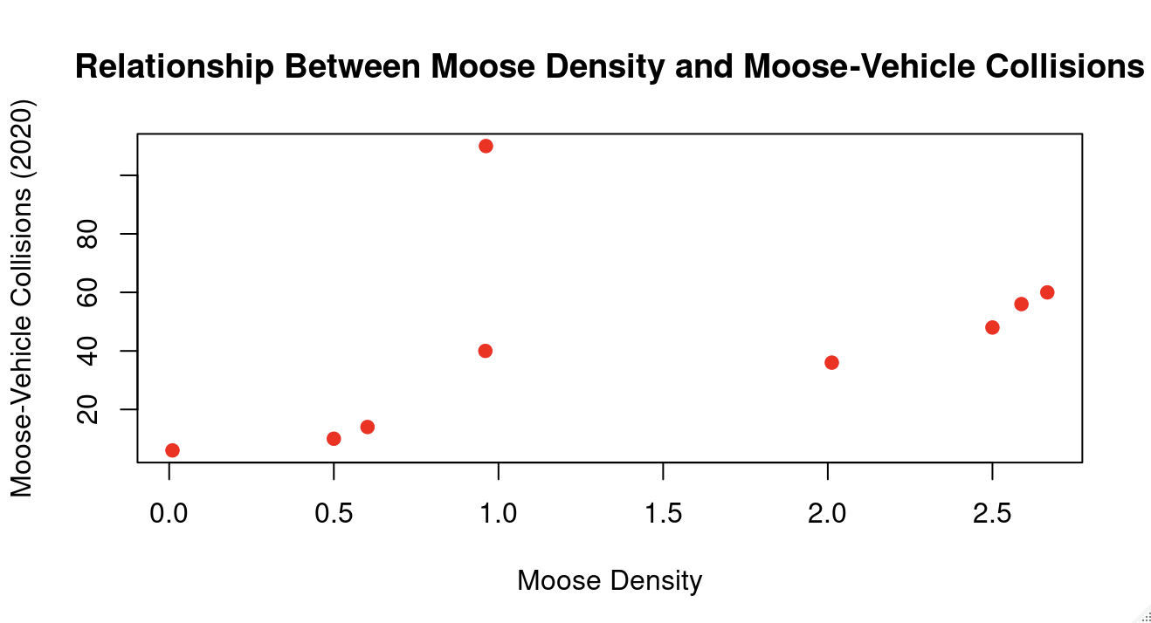

B #There is a linear trend where the higher moose densitys correlate to more moose-vehicle collisions. There is one outliers where the moose density is 1 but there are over 100 collisions.

7. coll_merge_per_capita <- mutate(coll_merge,coll_per_capita = collisions2020 / human_pop)

8. plot( coll_merge_per_capita$human_pop, coll_merge_per_capita$coll_per_capita, xlab = "Human Population", ylab = "Collisions per Capita", main = "Moose Collisions per Capita vs. Human Population", pch = 19, col = "blue" )

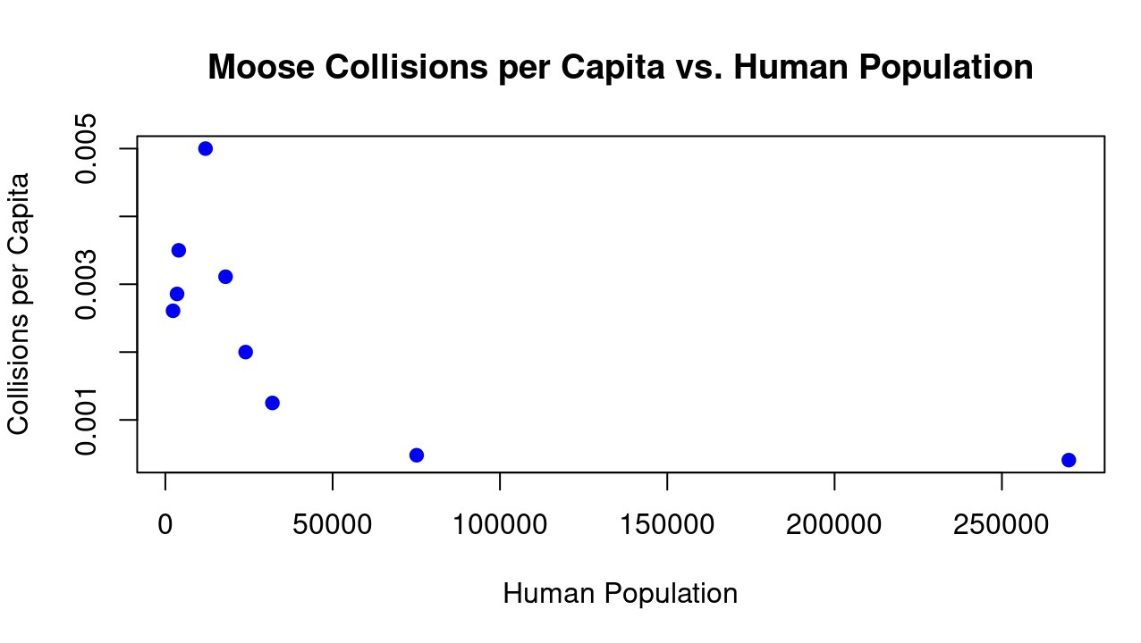

9. #I see trends that in areas with less people there are more collisions per capita and when theres more people the collisions per capita goes down. Yes this trend makes sense to me because in smaller communitys there will be more moose because of less human interaction with the environment so there is more moose which will cause more accidents to a less amount of people when in st.johns theres less room for moose but also a lot more people so if someone gets in a collison with a moose it won't effect the collisions per capita as much.

